# Write a program to count vowels in given file

fobj=open("file1.txt","r")
c=0
while True:
ch=fobj.read(1)
if ch=='':
break
if ch in "aeiouAEIOU":
c=c+1

print(f'Count of vowels {c}')

Output
Count of vowels 22

Example:
# Write a program to copy content of one file inside another file

fobj1=open("file1.txt","r")
fobj2=open("file2.txt","w")

s=fobj1.read()
fobj2.write(s)

print("File Copied")
fobj1.close()
fobj2.close()

Output
File Copied

Example:
# Write a program to save student marks details inside
# marks.txt file

try:
fobj1=open("marks.txt","a")
while True:
rollno=int(input("Rollno:"))
name=input("Name:")
sub1=int(input("Subject1Marks:"))
sub2=int(input("Subject2Marks:"))
fobj1.write(f'{rollno},{name},{sub1},{sub2}\n')
ans=input("Add another student?")
if ans=="no":
break
except OSError:
print("unable to create file")
except ValueError:
print("input only integer values")
finally:
fobj1.close()

Output
Rollno:1
Name:naresh
Subject1Marks:50
Subject2Marks:60
Add another student?yes
Rollno:2
Name:suresh
Subject1Marks:70
Subject2Marks:80
Add another student?yes

Example
# Write a program to find result of all the students
# exists within marks.text

try:
fobj=open("marks.txt","r")
while True:
stud=fobj.readline()
if stud=='':
break
rollno,name,sub1,sub2=stud.split(",")
total=int(sub1)+int(sub2)
avg=total/2
result="PASS" if int(sub1)>=40 and int(sub2)>=40 else "FAIL"
print(f'{rollno}\t{name}\t{int(sub1)}\t{int(sub2)}\t{total}\t{avg:.2f}\t{result}')

Output
1 naresh 50 60 110 55.00 PASS
2 suresh 70 80 150 75.00 PASS
3 kiran 30 40 70 35.00 FAIL
4 kishore 60 80 140 70.00 PASS
5 raman 20 30 50 25.00 FAIL

CSV files
CSV stands for Comma Separated Values
A CSV (Comma-Separated Values) file is a plain text file, identified by the .csv extension, used to store structured, tabular data like spreadsheets or databases. Each line represents a row, with commas separating data fields (columns). It is a widely supported, human-readable format for importing/exporting data between different applications.
For working with csv files, python is provided a predefined module called “csv”.

The csv module implements classes to read and write tabular data in CSV format. It allows programmers to say, “write this data in the format preferred by Excel,” or “read data from this file which was generated by Excel,” without knowing the precise details of the CSV format used by Excel. Programmers can also describe the CSV formats understood by other applications or define their own special-purpose CSV formats.

“csv” module provides the following classes for reading and write data in csv format.

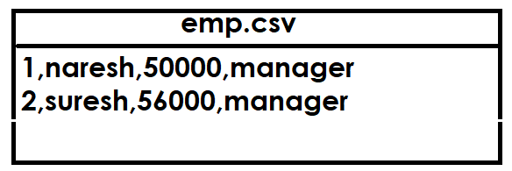

- Writer class
- Reader class
- DictWriter class
- DictReader class

The csv module’s reader and writer objects read and write sequences. Programmers can also read and write data in dictionary form using the DictReader and DictWriter classes.

Writer class
csv.writer(csvfile)
Return a writer object responsible for converting the user’s data into delimited strings on the given file-like object. csvfile can be any object with a write() method. If csvfile is a file object, it should be opened with newline=''

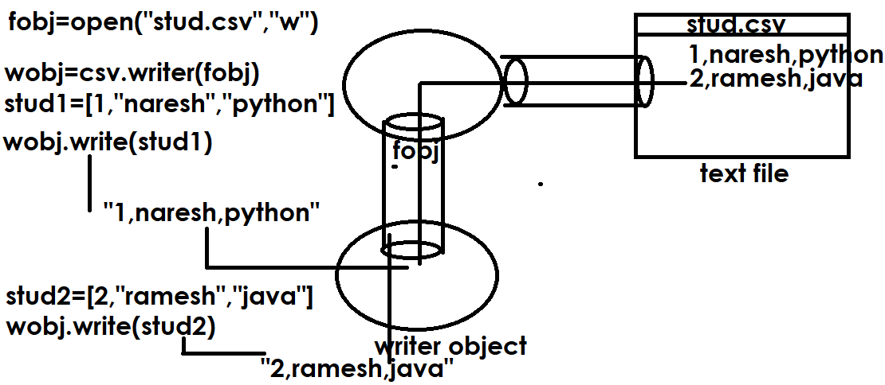
# Write a program to create student.csv file
# and store student details, each student is having
# rollno,name,course
import csv
try:
fobj=open("student.csv","a",newline='')
wobj=csv.writer(fobj)
while True:
rollno=int(input("Enter Rollno :"))
name=input("Enter Name :")
course=input("Enter Course :")
stud=[rollno,name,course]
wobj.writerow(stud)
ans=input("Add another student?")
if ans=="no":
break
except OSError:
print("not able to create file")
except ValueError:
print("input only integer values")
finally:
fobj.close()

Output
Enter Rollno :1
Enter Name :naresh
Enter Course :python
Add another student?yes
Enter Rollno :2
Enter Name :suresh
Enter Course :java
Add another student?yes
Enter Rollno :3
Enter Name :kishore
Enter Course :c++

reader object

Return a reader object that will process lines from the given csvfile. A csvfile must be an iterable of strings, each in the reader’s defined csv format. A csvfile is most commonly a file-like object or list. If csvfile is a file object, it should be opened with newline=''

reader(csvfile)

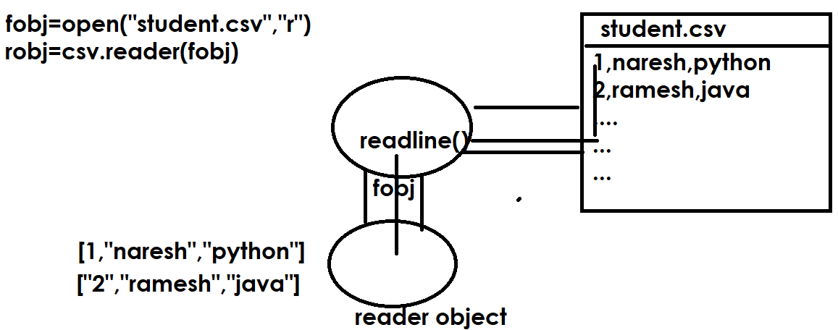

Example:
# Write a program read data from student.csv file

import csv
fobj=open("student.csv","r",newline='')
robj=csv.reader(fobj) # iterator
for stud in robj:
print(stud)

fobj.close()

Output
['1', 'naresh', 'python']
['2', 'suresh', 'java']
['3', 'kishore', 'c++']
['4', 'raman', 'oracle']
['5', 'kiran', 'mysql']

DictWriter object
class csv.DictWriter(f, fieldnames)
Create an object which operates like a regular writer but maps dictionaries onto output rows. The fieldnames parameter is a sequence of keys that identify the order in which values in the dictionary passed to the writerow() method are written to file f.

Example:
# Write a program create employees.csv file
import csv
fobj=open("employees.csv","a",newline='')
dwobj=csv.DictWriter(fobj,fieldnames=['empno','ename','salary'])
dwobj.writeheader()
while True:
empno=int(input("Enter EmployeeNo :"))
ename=input("Enter EmployeeName :")
salary=float(input("Enter EmployeeSalary :"))
emp={'empno':empno,'ename':ename,'salary':salary}
dwobj.writerow(emp)
ans=input("Add another employee?")
if ans=="no":
break

fobj.close()

Output
Enter EmployeeNo :1
Enter EmployeeName :Naresh
Enter EmployeeSalary :45000
Add another employee?yes
Enter EmployeeNo :2
Enter EmployeeName :Suresh
Enter EmployeeSalary :56000
Add another employee?yes
Enter EmployeeNo :3
Enter EmployeeName :kishore
Enter EmployeeSalary :45000
Add another employee?no

DictReader object
class csv.DictReader(f, fieldnames=None)
Create an object that operates like a regular reader but maps the information in each row to a dict whose keys are given by the optional fieldnames parameter.

# Write a program read data from employees.csv file

import csv
fobj=open("employees.csv","r",newline='')
drobj=csv.DictReader(fobj,fieldnames=['empno','ename','salary'])

for emp in drobj:
print(emp['empno'],emp['ename'],emp['salary'])

fobj.close()

Output
empno ename salary
1 Naresh 45000.0
2 Suresh 56000.0
3 kishore 45000.0

Json files

.

